f

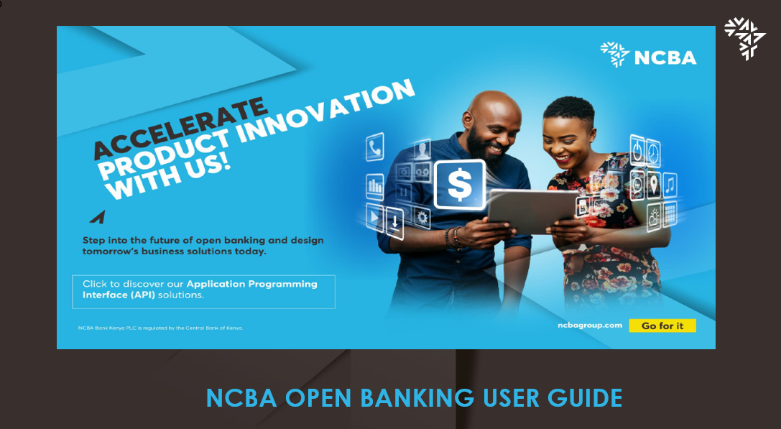

OPEN BANKING- UAT GUIDE
This is a top-level developer guide on how to conduct open banking UATs on postman before eventual migration to prod.
This will assist with proper payload creation and configuration to the expected responses.
Once successfully registered on the UAT environment and the IP whitelisted, you will then be able to access the URL below via the postman collection shared
https://openbankingtest.api.ncbagroup.com/test/apigateway/

To be able to utilize the endpoints, you will need to generate a token with the provided username, password and subscription key using the payload below:

{
"userID": "string",
"password": "string"
}
The input & response:
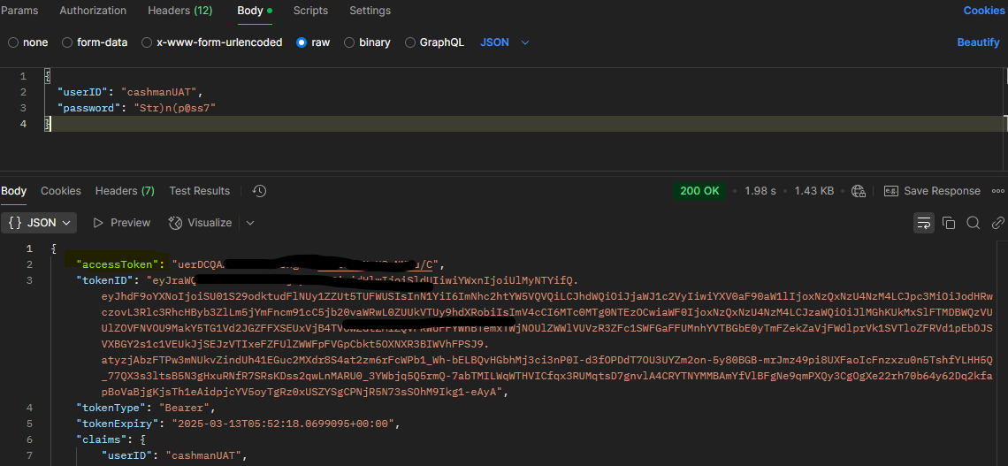

With resultant token, you can go ahead to test the other end points for payments and queries with the only difference on the header being addition of the bearer token.
Kindly note to input the word “Bearer” before every token
E.g Bearer uerDCQAAAZMFdYUI8VlORwUx+lQCvJRLH7NHd

Below is a sample of all required inputs on the header

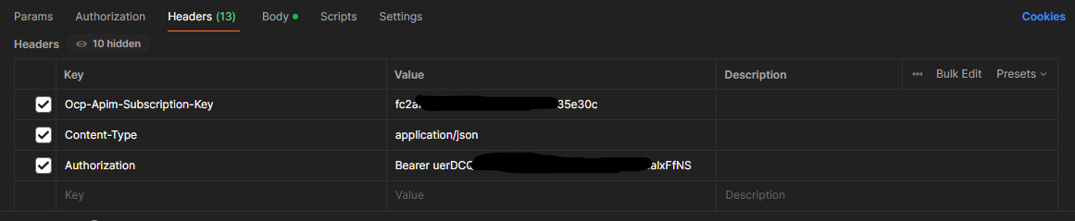

NB : All endpoints will be prefixed with the base URL.
Below are all the payloads required for your testing

HELLO WORLD !!

ELECTRONIC FUNDS TRANSFER (EFT) – To Local Bank Accounts
Request
{
"Amount": "String", (Amount in whole numbers)
"BeneficiaryAccountNumber": " String", ( Recipient Account number)
"BeneficiaryBankBIC": " String ", (Beneficiary Bank and Branch Code)
"BeneficiaryName": " String", (Beneficiary Account Name)
"Currency": "KES", (Only in local currency)
"DebitAccountNumber": "1234560000", (Sender Account Number)
"Narration": " String", (Alphanumeric payment details)- 16 characters max
"SenderCountry": "Kenya", (Kenya/Uganda/Tanzania/Rwanda)
"TransactionID": " String", (Unique Transaction Ref)
"SenderCIF": "123456" (Customer number – first 6 digits of the sender account number or any other assigned customer number as guided by NCBA)
}
Response
{
"resultCode": "000",
"statusDescription": "SUCCESS",
"cbxReferenceNumber": "IFT123454-3",
"txnReferenceNo": "FTX24211TAACS"
}

Payment Rules
- Transaction can be settled in only in local currency, KES, UGX, TZS & RWF.
- Payments will be within country of origin, local b2b.
- Minimum payments of KES. 50 or its equivalent in other currency and a maximum of KES. 999,999 or it’s equivalent in other local currency.
- Transactions processing is only on working days, Monday – Friday, excluding Weekends and Public Holidays

ACCOUNT MINI-STATEMENT
Request
{
"Country": "String", (Kenya/Uganda/Tanzania/Rwanda)
"AccountNo": "String" (NCBA linked account number)
}

Response
{
"ErrorCode": "000",
"ErrorMessage": "success",
"UnitID": "UG0010001",
"AccountNumber": " String ",
"AccountType": 1,
"Currency": "UGX",
"AvailableBalance": " String",
"MiniStatementList": [{
"ValueDate": "02052024",
"UniqueTransactionLegNo": "205773727455831.000002",
"TransactionCode": "213",
"TransactionCodeDescription": "Transfer",
"TransactionAmount": "30000000.00",
"CreditDebitFlag": "Credit",
"TransactionCurrency": "UGX",
"TransactionReference": "FT241238JVL3",
"Narrative": " TRANSFER",
"PaymentDetails": "TRANSFER",
"CreditReference": ""
}

INTERNAL FUNDS TRANSFER – TO NCBA ACCOUNTS
Request
{
"Country": "String", (Kenya/Uganda/Tanzania/Rwanda)
"TransactionID": " String ", (Alphanumeric Unique Reference)
"BeneficiaryAccountName": "String ", (Recipient Account Name)
"DebitAccountNumber": " String", (Remitter Account number)
"CreditAccountNumber": " String", - (Recipient Account number)
"Currency": " String", (KES/UGX/TZS/USD,GBP/EUR)
"Amount": " String", (Whole numbers, no odd cents allowed, only .50/.55)
"Narration": " String" (alphanumeric narrations)
}

Response
{
"resultCode": "000",
"statusDescription": "SUCCESS",
"cbxReferenceNumber": "IFT123454-3",
"txnReferenceNo": "FTX24211TAACS"
}

Payment Rules
- Transaction can be settled in all major currencies, i.e. KES, UGX, TZS, RWF, EUR, GBP & USD.
- Settlement is immediate; real-time.
- Payments will be within country of origin, local b2b.
- Minimum payments of KES. 50 or its equivalent in other currency, no limit on Maximum payment.
- Transactions processing is 24/7 – 365, including weekends and public holidays.

FX DEAL RATE
Retrieve Outstanding and Historical Foreign Exchange deal rates.
REQUEST
{
"country":"KE",
"cif":"String", (Customer number assigned by bank or first six digits of the Account number)
"dealRefNum":""
}

RESPONSE
{
"ErrorCode": "000",
"ErrorMessage": "success",
"UnitID": "KE0010001",
"CIF": " String ",
"DealRateList": [
{
"ErrorCode": "000",
"ErrorMessage": "success",
"DealReferenceNo": "FX2405160305",
"DealRate": "149.00",
"dealDate": "02122023",
"dealCurrencyTo": "KES",
"DealBookingAmount": "1782.00",
"Balance": "265518.00",
"AmtBuyBalance": "1782.00",
"AmtSellBalance": "265518.00",
"dealCurrency": "USD"
}
}

ELECTRONIC FUNDS TRANSFER (EFT) – To Local Bank Accounts
Request
{
"Amount": "String", (Amount in whole numbers)
"BeneficiaryAccountNumber": " String", ( Recipient Account number)
"BeneficiaryBankBIC": " String ", (Beneficiary Bank and Branch Code)
"BeneficiaryName": " String", (Beneficiary Account Name)
"Currency": "KES", (Only in local currency)
"DebitAccountNumber": "String", (Sender Account Number)
"Narration": " String", (Alphanumeric payment details)
"SenderCountry": "String", (Kenya/Uganda/Tanzania/Rwanda)
"TransactionID": " String", (Unique Transaction Ref)
"SenderCIF": "String" (Customer number – first 6 digits of the sender account number or any other assigned customer number as guided by NCBA)
}
Response
{
"resultCode": "000",
"statusDescription": "SUCCESS",
"cbxReferenceNumber": "IFT123454-3",
"txnReferenceNo": "FTX24211TAACS"
}

Payment Rules
- Transaction can be settled in only in local currency, KES, UGX, TZS & RWF.
- Settlement is processed T+ 1 day.
- Payments will be within country of origin, local b2b.
- Minimum payments of KES. 50 or its equivalent in other currency and a maximum of KES. 999,999 or it’s equivalent in other local currency.
- Transactions processing is only on working days, Monday – Friday, excluding Weekends and Public Holidays.

Charge Enquiry **
Retrieve charges applied on associated transactions within the account.

Request

{
"country": "KE",
"serviceType": "RTGS",
"debitAccount": "String", (Sender Account number)
"chargeCurrency": "KES",
"transactionAmount": "20"
}

Response

{
"ErrorCode": "000",
"ErrorMessage": "SUCCESS",
"UnitId": "KE0010001",
"ServiceType": "RTGS",
"ChargeCurrency": "KES",
"DebitAccount": "1234567890",
"ChargeAmount": "0.0"
}

NCBA ACCOUNT STATEMENT
Request
{
"Country":"String", (Kenya/Uganda/Tanzania/Rwanda)
"AccountNo":" String", (NCBA linked account number)
"FromDate":"26052022",
"ToDate":"05062022"
}
Response
{
"ErrorCode": "000",
"ErrorMessage": "success",
"AccountNumber": " String ",
"AccountName": " String",
"StartDate": "26052022",
"EndDate": "05062022",
"Currency": "KES",
"AvailableBalance": "519735.83",
"OpeningBalance": "0.00",
"ClosingBalance": "0.00",
"TotalDebit": "201140.00",
"TotalCredit": "2000000.00",
"TotalTxn": 8,
"AccountList": [{
"ValueDate": "30052022",
"UniqueTransactionLegNo": "198743388241139.020001",
"CreditAmount": "2000000.00",
"DebitAmount": "",
"RunningBalance": "2000000.00",
"CreditDebitFlag": "CREDIT",
"TransactionSeqNo": 1,
"Narrative": "INTERNAL TRANSFE",
"AdditionalReference": "INTERNAL TRANSFE",
"InstrumentReferenceNumber": "FT22150MFK15",
"TransactionCode": "1015",
"TransactionCodeDescription": "Inward Telex Payment",
"TransactionCurrency": "KES",
"PaymentDetails": "",
"CreditReference": ""
}

KPLC POST-PAID PAYMENTS
Process your postpaid KPLC payments through NCBA Open banking APIs.

REQUEST
{
"validationId":"String", (generated from KPLC validation)
"customerName":" String ", (meter holder name)
"meterNumber":" String ", (numeric meter number)
"msisdn":" String ", (mobile number for notifications)
"channelRef":" String ", (customer unique reference)
"amount":" String", (whole numbers only)
"callbackUrl":"", (optional url)
"reason":"KPLC PAYMENT",
"accountNumber":" String " (sender account number)
}

RESPONSE
{
"data": {
"id": "dd0cad58-fcea-44f0-a5b7-0a0db3369f13",
"channelRef": "TBC087UZ97Q1",
"bankRef": "FTX24250MAAAH",
"message": "SUCCESS"
},
"statusCode": 200,
"message": "Success",
"succeeded": true
}

Payment Rules
- Payments in KES only.
- Payments to allow for Bill due, underpayment and overpayment.
- Payments processed with generated validation ID only.

KPLC POST-PAID VALIDATION
This is a validation service to check the account/meter number validity and confirm balance due.

Request
{
"meterNumber": "String", (numeric meter number)
"msisdn": "String" (phone number under bill)
}

Response
{
"validationId": "b2fef8dd-955d-4034-eecd-08dcbac3a85b",
"meterNumber": " String ",
"customerName": " String ",
"serviceName": "Kplc Postpaid",
"balance": 136.07,
"statusCode": 200,
"message": "",
"succeeded": true
}

KRA PAYMENT (Kenya Revenue Authority)
Process your KRA Payments through our Tax Payment API to settle I-Tax, Excise Duty and VAT.
You will be able to utilize this API after validation your KRA E-Slip number using the KRA Validation API.

REQUEST
{
"validationId":"String", (Retrieved from KRA Validation query)
"customerName":" String ", (Retrieved from KRA Validation query)
"eslipNumber":" String ", (KRA control number)
"msisdn":"254727455575", (Associated phone number)
"channelRef":"TBC087UZ97S1", (Client Alphanumeric Unique Reference)
"amount":"43417.0", ((Retrieved from KRA Validation query) on amount due)
"callbackUrl":"", (Optional client url)
"reason":"KRA PAYMENT",
"accountNumber":"6631200761", (Sender Account number)
"paymentType":"iTax" (Tax obligation)
}

RESPONSE
{
"data": {
"id": "be8e01fe-d55b-4aea-a993-72cf72f0bfc2",
"channelRef": "TBC087UZ97S1",
"bankRef": "FTX24250MAAGM",
"message": "SUCCESS"
},
"statusCode": 200,
"message": "Success",
"succeeded": true
}

KRA VALIDATION (TAX PAYMENT PREREQUISITE)
Validation the tax obligation using your KRA E-Slip number to confirm validity and details for payment.
This is a prerequisite for KRA Payment.

REQUEST
{
"eslip": " String ", (Alphanumeric E-slip)
"msisdn": " String ", (Associated mobile number)
"paymentType": "String" (Tax obligation)
}

RESPONSE
{
"validationId": "d6a21132-6200-4212-6135-08dcccbfbdd0",
"customerRef": "2420240009233218",
"customerName": "TTLE 051692TEST",
"serviceName": "KRA",
"balance": 2000.0,
"statusCode": 200,
"message": "",
"succeeded": true
}

LIPA NA MPESA PAYMENT API (LNM)
Make payments to Till Numbers and PayBill Numbers using the Bank to Merchant API.
REQUEST
{
"reqTransactionReferenceNo": "LIPANAMPESA059",
"reqPaymentType": "Paybill", (Paybill or Till)
"reqPayBillTillNo": "247247",
"DebitAccountNumber": "123456543",
"DebitAmount": "200",
"reqCreditAmount": "200",
"reqDebitAcCurrency": "KES",
"reqToAccountName": "JOHN NDORE",
"reqMobileNumber": "",
"reqPaymentDescription": "Mandazi",
"reqPaybillAccount": "0987656789",
"Country": "KENYA"
"reqChnlId": "LNMTest001" //Unique ID
}

RESPONSE
{
"hdrRefNo": "1",
"hdrTranId": "SHSJKKE",
"resCbxReferenceNo": "TBS2408190059403",
"resCoreReferenceNo": "FTX24232FAAAO",
"resErrorCode": "000",
"resErrorDesc": "SUCCESS",
"resErrorMessage": "SUCCESS",
"UnitId": "KE0010001"
}

LIPA NA MPESA VALIDATION (LNM)
Validate the Paybill number and Till number for Payment facilitation.
This is a prerequisite for Bill Payments.

IdentifierType (paybill 4 : till 2)

Request
{
"Identifier":"String", (Paybill/Till)- Till 300014
"IdentifierType":"2"
}

Response
{
"errorCode": "000",
"errorMessage": "Success",
"origanizationShortCode": "9380435",
"OrganizationName": "String"
}

Mpesa Agent Validation
Validate Agent Number for Float Purchase.
This is a prerequisite API call for purchasing float from Safaricom Mpesa.

Request
{
"Country": "Kenya",
"AgentCode": "122-96519" (MPesa Agent Code)
}

Response
{
"ErrorCode": "000",
"ErrorMessage": "success",
"AgentCode": "122-96519",
"AgentName": "JANE DOE",
"AgentAccount": "String"
}
M-PESA FLOAT PURCHASE
Purchase M-Pesa float via the NCBA/Safaricom API and experience automatic float settlement to your merchant account.
This is a 24-Hour service.

REQUEST
{
"reqAgentName": "String", (Retrieved from Validation Call)
"reqCreditAmount": " String ", (Amount in Whole numbers)
"reqCustomerReference": " String ", (Optional Ref)
"reqDealReference": "", (Applicable for Cross-currency)
"reqDebitAccountNumber": " String ", (Sender Account Number)
"reqDebitAcCurrency": "KES",
"reqDebitAmount": " String ", (Amount in Whole numbers)
"reqMobileNumber": "", (Optional for notification)
"reqPayBillTillNo": " String ", (Retrieved from Validation Call)
"reqPaymentDescription": " String ",
"reqPaymentType": "MPesaHolding", (can be either MpesaHolding or MpesaSuperAgency)
"reqToAccountName": " String ", (Field)
"reqTransactionReferenceNo": "String", (Alphanumeric Unique Reference)
"reqTxnDate": "06092024", (Optional)
"SenderCountry": "Kenya"
}

RESPONSE
{
"hdrRefNo": "1",
"hdrTranId": "SHSJKKE",
"resCbxReferenceNo": "TBS2409060060265",
"resCoreReferenceNo": "FTX24250MAADK",
"resErrorCode": "000",
"resErrorDesc": "SUCCESS",
"resErrorMessage": "SUCCESS",
"UnitId": "KE0010001"
}
MPESA PAYMENT
Process Bank to Wallet Payments to recipient’s Mpesa numbers for amounts between KES. 50.00 – KES. 250,000 Per transaction.
Endpoint: /api/v1/MobileMoneyTransfer/mobilemoneytransfer
REQUEST
{
"beneficiaryName": "String", (Beneficiary name)
"date": "2025-05-12", (YYYY-MM-DD)
"debitAccount": "String", (NCBA debit account number)
"debitAmount": "String", (Debit amount- two decimal places/ whole numbers)
"mobileNumber": "String", (MPesa beneficiary starting with 254)
"transactionNarration": "OB-transaction", (Narration)
"uniqueReferenceNumber": "OB-104PQ231" (Unique transaction ID)
}

RESPONSE
{
"data": {
"id": "76a1bd1c-ded2-4f98-0aba-08dcc83de465",
"channelRef": "TRIAGE 123",
"bankRef": "FTX24242AAQVT",
"message": "SUCCESS"
},
"statusCode": 200,
"message": "Success",
"succeeded": true
}

MPESA VALIDATION- WIP
Retrieve Validation ID required for MPesa payment processing.
This is a prerequisite for MPesa payments.

REQUEST
{
"msisdn": "254799401110" (Recipient phone number)
}

RESPONSE

{
"validationId": "08dcc836-427e-45de-f658-6d216fd10000",
"customerMsisdn": "254799401110",
"minimumPaymentAmount": 50.0,
"statusCode": 200,
"succeeded": true
}
M-Shwari Payment
Process funds transfer of up to 999,999 to MShwari Accounts.
This API is only applicable to MShwari registered Phone Numbers.

REQUEST
{
"reqCreditAmount": "200.00",
"reqDebitAccountNumber": "9115310018",
"reqDebitAcCurrency": "KES",
"reqMobileNumber": "254712345678",
"reqPaymentDescription": "test",
"reqToAccountName": "Peter Sijenje",
"reqTransactionReferenceNo": "MshwariNonIMT001",
"SenderCountry": "Kenya",
"reqChnlId":"MshwariNonIMT001"
}

RESPONSE
{
"hdrRefNo": "1",
"hdrTranId": "23456",
"resCbxReferenceNo": "TBC2406241611185",
"resCoreReferenceNo": "FTX24236PAABO",
"resErrorCode": "000",
"resErrorDesc": "SUCCESS",
"resErrorMessage": "SUCCESS",
"UnitId": "KE0010001"
}

NAIROBI CITY WATER & SEWERAGE COMPANY PAMENT (NCWSC)
Pay your Nairobi water utility to NCWSC for automatic bill update.
Consume the callback to receive acknowledgement from Nairobi Water.

REQUEST
{
"validationId":"string", (Retrieved from validation request)
"customerName":" string", (Retrieved from validation request)
"meterNumber":" string ", (Retrieved from validation request)
"msisdn":" string ", (Optional for notification)
"channelRef":" string ", (Client Unique ref)
"amount":" string ", (Amount Payable)
"callbackUrl":"", (Optional for notification)
"reason":"NW PAYMENT REQUEST",
"accountNumber":" string" (Sender Account Number)
}

RESPONSE

{
"data": {
"id": "cc128db8-1e4f-4aa3-9c13-69549d0192aa",
"channelRef": "TBCUNIQUE111",
"bankRef": "FTX24255XAACN",
"message": "SUCCESS"
},
"statusCode": 200,
"message": "Success",
"succeeded": true
}
NAIROBI CITY WATER & SEWERAGE COMPANY VALIDATION (NCWSC)
This is a validation service to check the account/meter number validity and confirm balance due.
Request
{
"meterNumber": "String", (numeric meter number)
"msisdn": "String" (phone number under bill)
}

Response
{
"validationId": "String",
"meterNumber": " String ",
"customerName": " String ",
"serviceName": "Nairobi Water",
"balance": 11603.26,
"statusCode": 200,
"message": "",
"succeeded": true
}

PESALINK PAYMENT – To Local Bank Accounts
Request
{
"BeneficiaryAccountNumber": "String",( Recipient Account number)
"BeneficiaryBankBIC": " String ", (Beneficiary Bank Code prefixed with 00 (zero zero) )
"BeneficiaryName": "JANE DOE", (Beneficiary Account Name)
"Amount": "100.00", (Amount in whole numbers)
"Currency": "KES",(Only in KES)
"Narration": "Trial pesalink", (Alphanumeric payment details)
"SenderAccountNumber": "String", (Sender Account Number)
"SenderCIF": " String ",(Customer number – first 6 digits of the sender account number or any other assigned customer number as guided by NCBA)
"SenderCountry": " String ", (Kenya Only)
"TransactionID": " String" (Unique Transaction Ref)
}

Response
{
"resultCode": "000",
"statusDescription": "SUCCESS",
"cbxReferenceNumber": "Test Pesalink",
"txnReferenceNo": "FTX24211TAACS"
}
Payment Rules
- Transaction settled in KES only.
- Settlement is processed immediately.
- Payments will be within Kenya only.
- Minimum payments of KES. 50 or its equivalent in other currency and a maximum of KES. 999,999 or it’s equivalent in other local currency.
- Payments are settled 24/7-365, including weekends and public holidays.

REAL TIME GROSS SETTLEMENT (RTGS) – TO OTHER LOCAL BANK ACCOUNTS
Request
{
"BeneficiaryAccountNumber": "String", (Recipient Account number)
"BeneficiaryBankBIC": " String ", (Beneficiary bank SWIFT Code)
"BeneficiaryCountry": " String ", (Country- KE/UG/TZ/RW)
"BeneficiaryName": "John Doe",(Recipient Name)
"BeneficiaryAddress": "Nairobi", (Beneficiary address)
"CreditAmount": " String ", (Amount in whole numbers, no odd cents)
"DebitCurrency": " String ", (Currency of Sender account)
"CreditCurrency": " String ", (KES/USD/GBP/EUR/TZS/UGX,RWF)
"Narration": " String ", (alphanumeric narration)
"SenderAccountNumber": " String ", (Remitter Account number)
"SenderCIF": " String ", (Customer number – first 6 digits of the sender account number or any other assigned customer number as guided by NCBA)
"SenderCountry": " String ", (KE/TZ/UG/RW)
"PurposeCode": "String", (Purpose of Payment Code – List to be provided by Bank)
"TransactionID": " String " (Alphanumeric Unique Reference)
}
Response
{
"resultCode": "000",
"statusDescription": "SUCCESS",
"cbxReferenceNumber": "String",
"txnReferenceNo": "FTH9797UHBACS"
}

Payment Rules
- Transaction settled in KES, USD,GBP,EUR,TZS,UGX & RWF.
- Settlement is T+ 3hours on a working day, typically Monday – Friday before 15.00 HRS EAT.
- Payments will be within Country of Origin.
- Minimum payments of KES. 50 or its equivalent in any other acceptable currency with no maximum CAP.
- Purpose of Payment Code (POP) will be required for all outgoing payments - The list of POP codes to be maintained to be shared during onboarding.

TRANSACTION ADVISE
Generate a transaction receipt for your payment.
Request
{
"country": "KE",
"transactionId": "String" Bank reference number(FT****)
}

Response
{
"ErrorCode": "000",
"ErrorMessage": "success",
"UnitID": "KE0010001",
"FtReference": "String", Bank Ref no. (FTX24220UAAAN)
"TransactionType": "ACIT",
"CreditCcy": "KES",
"CreditAmount": "100.00",
"CreditAccountNumber": " String",
"TotalCharges": " String ",
"SenderRef": " String",
"CreditedAt": "05042024",
"CreditAcctTitle": " String ",
"DEBITCcy": "KES",
"DebitAccountNo": " String " Remitter Account Number
}

Transaction Status – Check Success/Failure of a transaction

Request
{
"country": "String", (KE/UG/TZ/RW)
"transactionId": "String" (Alphanumeric unique reference)
}
Response
{
"ErrorCode": "000",
"ErrorMessage": "success",
"TransactionId": " String",
"CoreReference": "String" (core banking ref)
}

LOOP transfer payload

{
"Country": "Kenya", //Kenya
"LoopAccount": "1234565432", //Loop account number
"LoopName": "James John Doe", //Beneficiary loop name
"TransactionReferenceNumber": "LoopTest5", // Unique reference
"AccountNumber": "9115310018", //Debit account number
"DebitAmount": "201", //Transfer Amount
"Narration": "DFTOUTONLINE_INTER", //Narration
"BeneficiaryAccount": "880200001288", //Loop account number
"BeneficiaryName": "Malcolm Juma" //Beneficiary loop name
}
E-citizen e-slip validation
Query to validate the E-slip number provided

{
"customerRef": "DGNZRJ", //Eslip number
"msisdn": "254721123456", //Mobile number
"currency":"USD" //Currency (USD/KES)
}
Response
{
"validationId": "6d7029cb-2064-4f2e-3b14-08ddfad7f8f4",
"customerRef": "DGNZRJ",
"customerName": "SamKim",
"serviceName": "ECitizen Payments",
"balance": 22.35,
"statusCode": 200,
"message": "Bill Found",
"succeeded": true
}

E-Citizen payment payload
Request to pay E-citizen

{
"amount": "22.35", //amount as captured during validation
"validationId": "6d7029cb-2064-4f2e-3b14-08ddfad7f8f4", // validation ID
"customerName": "SamKim", //Name as captured during validation
"accountNumber": "9115310018", //Debit account number
"customerRef": "WGNBMX", //E-Citizen e-slip number
"msisdn": "254721786885", //Mobile number
"channelRef": "TESTMASTER7", //Unique ID
"debitcurrency":"KES", //Debit currency (USD/KES/GBP/EUR)
"creditcurrency": "USD", //Credit currency (USD/KES)
"callbackUrl": ""
}

Response from a successful E-citizen
{
"data": {
"id": "4f33c7c2-c6a3-4377-9037-85f0d0498d3d",
"channelRef": "TESTMASTER7",
"bankRef": "FTX25268SAAAA",
"message": "SUCCESS",
"results": null
},
"message": "Success",
"succeeded": true,
"statusCode": 200,
"resultCode": "RDI.200.0.CBA.DFT",
"resultDesc": "Success"
}

SHA E-slip Validation
{
"customerRef": "12345", //E-slip as provided by SHA/SHIF
"msisdn": "254722123456" //Mobile number
}

Successful E-slip validation
{
"validationId": "2b2b107e-20ab-444e-954e-08de1796f98f",
"customerRef": "5569793",
"customerName": "NCBA Bank Ke",
"serviceName": "SHA",
"balance": 7800.0,
"statusCode": 200,
"message": "Success",
"succeeded": true
}

SHA Payment request

{
"amount": "2200.00", //Amount as per validation request
"validationId": "1b4fc8a0-805c-481e-a755-08de21f5c111", //Validation ID
"customerName": "NYANDIWA VALLEY DEVELOPMENT PROJECT", //Name as per validation
"accountNumber": "9115310018", //Debit account number
"customerRef": "QLE6GPVI", //E-Slip number
"msisdn": "254721786885", //Mobile number
"channelRef": "SHATE01" //Unique ID
}

Successful response
{
"data": {
"id": "b4fdc513-5890-431c-907c-8e75207e40d7",
"channelRef": "SHATE01",
"bankRef": "FTX25317FAAAC",
"message": "SUCCESS",
"results": null
},
"message": "Success",
"succeeded": true,
"statusCode": 200,
"resultCode": "RDI.200.0.CBA.DFT",
"resultDesc": "Success"
}

KPLC Prepaid account/meter validation
{
"meterNumber": "37155447917", //Meter number
"msisdn": "254727455575" //Mobile number to receive the token
}

Response for successful Validation
{
"validationId": "05e4ee84-3c44-4388-a76f-08de21f5c111",
"meterNumber": "37155447917",
"customerName": "Shaun Beahan",
"serviceName": "Kplc Postpaid",
"balance": 569.02,
"statusCode": 200,
"message": "Success",
"succeeded": true
}

KPLC Prepaid token purchase
{
"validationId": "05e4ee84-3c44-4388-a76f-08de21f5c111", // Validation ID
"customerName": "Shaun Beahan", //KPLC Customer name as per meter number
"meterNumber": "37155447917", // KPLC meter number
"msisdn": "254727455575", //Mobile number to receive the token number
"channelRef": "KPLCPREPAID5", //Unique Reference ID
"amount": "434.00", //Token Amount
"reason": "KPLC PAYMENT", //Narration
"accountNumber": "1234567890" //Debit account number
}

Successful response from purchase
{
"data": {
"id": "81e48715-cba2-4369-8f3c-c8c7493cf9b6",
"channelRef": "KPLCPREPAID7",
"bankRef": "FTX25317MAAAB",
"message": "SUCCESS",
"results": null
},
"message": "Success",
"succeeded": true,
"statusCode": 200,
"resultCode": "RDI.200.0.CBA.DFT",
"resultDesc": "Success"
}

